Reference Electrode Standardization Technique
----REST

User manual
（Version 1.0）

Key Laboratory for NeuroInformation of Ministry of Education
University of Electronic Science and Technology of China
2009-11

Contents

Copyright and Release statement 2
Operation Manual 3
Equipment requirment 3
Startup program 3
Total introduction of software interface 3
1. Main interface 3
2. Tools introduction 3
2.1. File 3
2.2 View 7
2.3. Reference 8
2.4. Help 9
References 10

Copyright and Release statement
- The trial version (V1.0) of the software REST is released through registation for free. For research and academic need, the using license can be applied.
- The copyright of the software and appendix information is held by Brain-Computer Interface Lab, Key Laboratory for NeuroInformation of Ministry of Education, University of Electronic Science and Technology of China, and is protected by laws.
- This software can be used with authorization, only for research and academic purposes. The key technique references (see this manual) should at least be cited when academic papers published with the application of this software. The software makes no permission for commercial purpose or diagnosis basis. Without warrant, in no event with the software be liable for use, copy, modification, transmission, excerption or bonding with any other production for any organizations or individuals. For any violation to this copyright statement, our lab has the right to cancel the use license, even to inquire the legal obligations.

Contacts:
Dezhong Yao Tel: +86-28-83201018 Mail: dyao@uestc.edu.cn
Key Laboratory for NeuroInformation of Ministry of Education,
University of Electronic Science and Technology of China
Chengdu, Sichuan
Application for REST software warrant
Name | Date | Organization | Contact | Research field | copyright
 |  |  |  |  | For research and academic purposes; not for commercial or diagnosis purpose; The key technique references should at least be cited.

Operation Manual
Technique support：If you have any problems or suggestion, please contact: dyao@uestc.edu.cn

Equipment requirment
Windows XP，Vista operation system
RAM requirement: above 512M
The best resolution：1400*900

Startup program
Run the REST.exe with the symbol , and the REST software is open.

Total introduction of software interface

1. Main interface
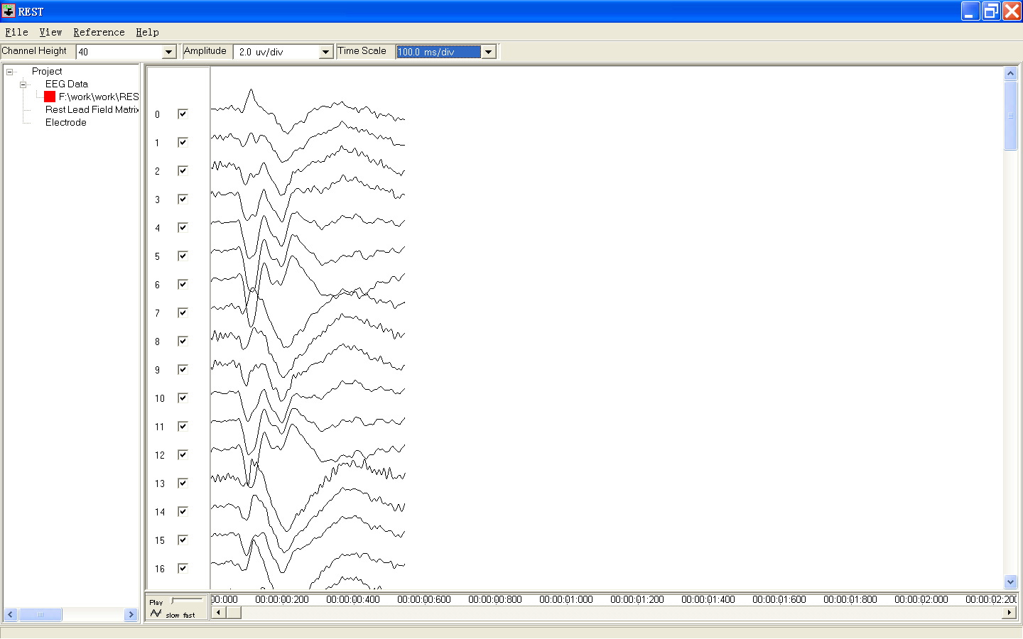
Amplitude control
time axis control
intervals for channel representation
waveform representation
workspace
tools
Figure 1. Interface configuration

2. Tools introduction
New Workspace：create new workspace
Load Workspace：Load the current workspace, that is, load the files recording with operating information.
Save Workspace： Save the operating information in current workspace for the next call.
Save Workspace As：save the current workspace as expected。
Export Reference Data：Export the data with current reference, with two formats txt and cnt. Set the reference with the menu ‘Reference’
Exit：Exit

2.1. File
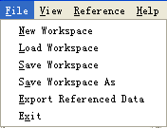
Click New Workspace to create the new workspace, and the operation variation can be automatically shown in work column as figure 2 showing：
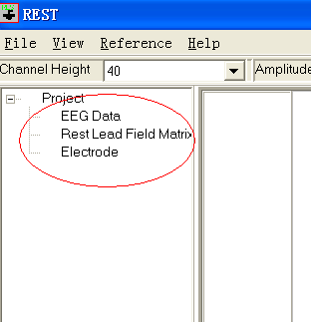

Figure 2. Workspace operation option
Performing the following steps to import the relative files:
a) EEG Data：to load EEG data file，click the right key on EEG Data, and the menu Load File pops-up, and then click and open the dialog box as figure.3 （choose the contents of EEG data，here is the demo）, and select the EEG file format: the .cnt , .avg and .txt format files.

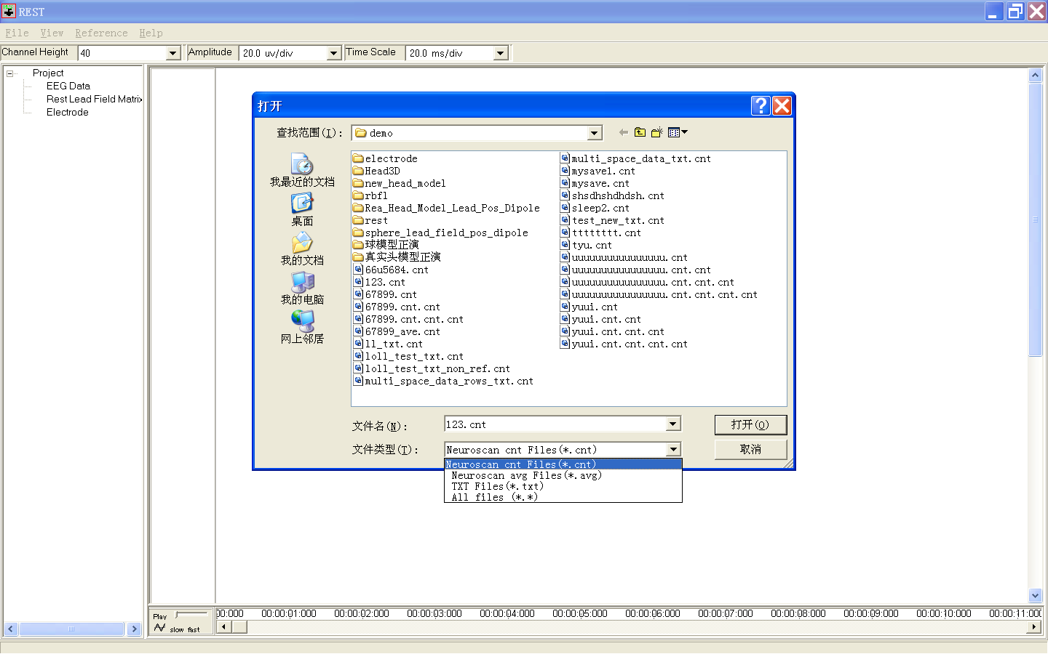
Figure 3. The file format selection interface to load EEG files
When the format of loaded files is .cnt or .avg, the files are read automatically;
When loading .txt files (if the user has save the data as .txt ), some simple intervene should be done:
After selecting the .txt files, the following operation interface occurs:
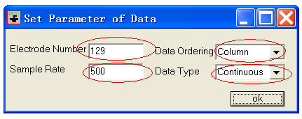
Figure 4. The interface to set parameters for .txt format data
Electrode Number: Input the recording electrode number of EEG data;
Data Ordering: Choose the EEG of each electrode ranked by column or row;
Sample Rate: Input the sample rate of EEG;
Data Type: Select the data pattern: continuous data or averaged data;
After setting the above, click OK button and the data are imported.

Notice: When the data are successfully imported, there is a red rectangle cue( as F:\work\..) to show the location of the imported data; Meanwhile, click the right key at the file directory, the menus pop-up as:
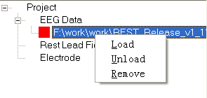
Figure 5. File load, unload, and remove control menu
Using these menus, these functions can be realized: Load, Unload and Remove.

b) Rest Lead Field Marix：To load the transfer matrix necessary in REST transformation. Click the right key and popup menu, click it and popup the following transfer matrix selection interface, choose the transfer matrix consistent with the electrode array of the recording EEG, e.g. EGI 128:
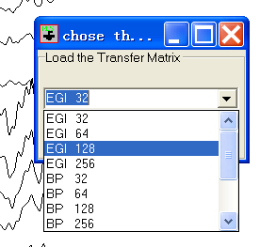
Figure 6. REST transfer matrix pattern selection interface
After choosing the transfer matrix pattern, the default transfer matrix will be loaded. Then the following interface pops-up:
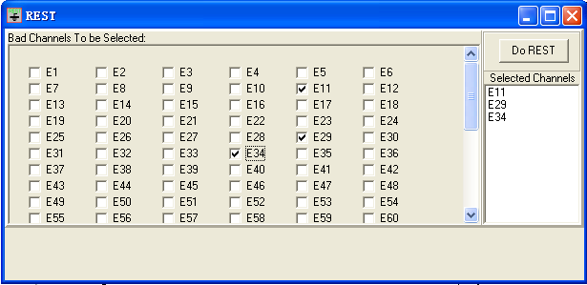
Figure 7. REST reference processing interface
Some channels with bad signals can be selected in the left column, then the bad channel can be recovered by interpolation, click
Do REST button to complete the re-reference calculation.
After loaded successfully and “Do REST”, bellow the ‘REST Lead Field Matrix’ the relative directory and a red rectangle cue will occur to show the position of the “ lead field matrix”.
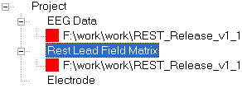
Figure 8. Label for Rest Lead Field loaded
Notice: 1）to complete REST re-reference, the consistent lead field matrix should be loaded.
2）REST re-reference completed with these steps done, choose export referenced data in File to export and save the data. Moreover, you can go to the step c), load the electrode information to the following view need.

c) Electrode：Click the right key at Electrode, and the menu Load File pops-up, click it, then electrode selection interface occurs.
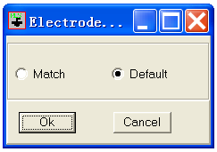
Figure 9. Electrode loading control interface

The two options in the interface stand for the following functions:
Match：match the electrode with the name ( 谁match 谁，具体的意思是什么，读不懂);
Default: Approve the electrode array order consistent with the loaded data;
讲在什么情况下，选 match, 什么情况下，选 default

After loading successfully; the corresponding file directory information will occur under the ‘Electrode’, and a red rectangle cue occurs before the directory.

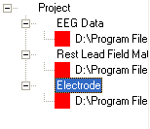
Figure 10. The symbol of data loaded successfully

2.2 View
Using precondition: after the whole contents, three red rectangles, loaded in the workspace (e.g. Figure 10), all the functions of View can be used.
View contents as follows:
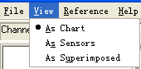
Figure 11. View menu
a) As Chart：showing the data with standard chart pattern, the waves showing as the following figure:

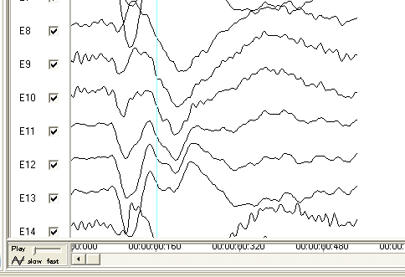
Figure 12. The standard demonstration of data
b) As Sensors：after the electrode array loaded, data can be shown in electrode positions, as the following figure:
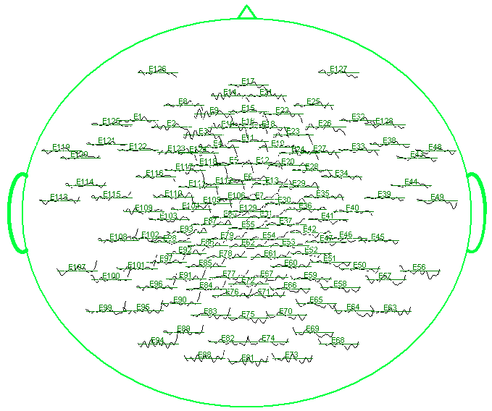
Figure 13. showing data in electrode positions
c) As Superimposed：showing the data in averaged pattern as:
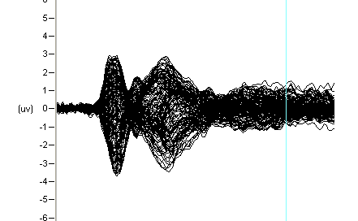
Figure 14. showing data in averaged pattern

2.3. Reference
Using the Reference menu, the switch among references can be conducted. When doing the switches, the waves showing in the right areas change with different reference.
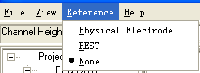
Figure 15. Reference switch menu

a). Physical Electrode：choosing the Physical Electrode, and then the dialog box pops-up, the common references styles can be done.
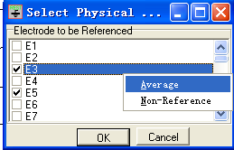
Figure 16. Physical reference choosing interface
Note: Click the right key, and you can choose the average reference (over all channels), the none-reference (default recording reference of the imported data), one or some electrodes as the reference (e.g. linked-mastoid reference), and show the figures.
B). REST：selecting the REST reference style to show the results of REST calculation.
C). None：selecting None-reference style, that is the original reference of the input data.

2.4. Help
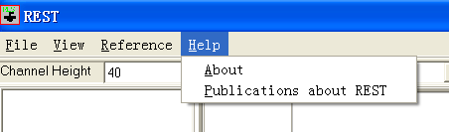
Figure 17. Help menu
Click Help，and choose About, then the relative information of this software can be found as:
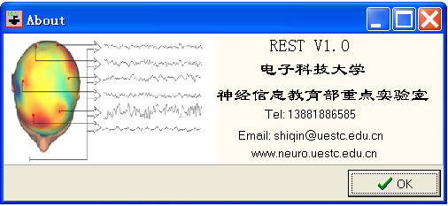
Figure 18. Software version information
Select Publications about REST, then the relative references about REST are shown in the following interface:
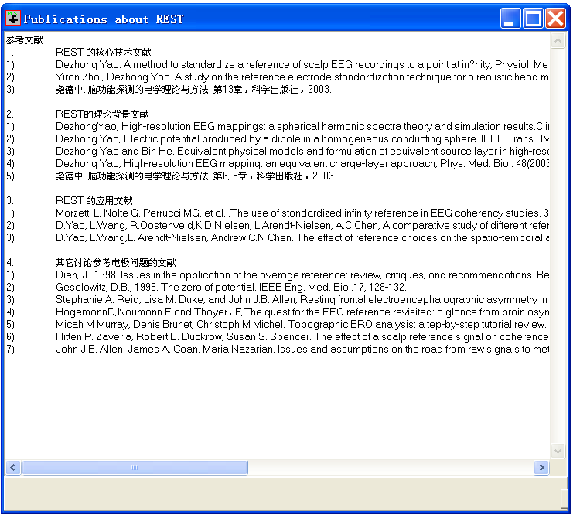
Figure 19. References about REST

References
References about the key technology of REST:
- Dezhong Yao. A method to standardize a reference of scalp EEG recordings to a point at inﬁnity, Physiol. Meas., 22(4) (2001) 693–711
- Yiran Zhai, Dezhong Yao. A study on the reference electrode standardization technique for a realistic head model, Comput. Meth. Programs Biomed., 76(2004) 229–238
- Yun Qin, Peng Xu, Dezhong Yao.A comparative study of different references for EEG default mode network: the use of the infinity reference. Clinical Neurophysiology, in press (2010).

References about theoretical background of REST:
- DezhongYao, High-resolution EEG mappings: a spherical harmonic spectra theory and simulation results,Clin. Neurophysiol. 111(2000) 81–92.
- Dezhong Yao, Electric potential produced by a dipole in a homogeneous conducting sphere. IEEE Trans BME, 47(7), 964-966, 2000
- Dezhong Yao and Bin He, Equivalent physical models and formulation of equivalent source layer in high-resolution EEG imang,Phys. Med. Biol.,48(2003), 3475–83
- Dezhong Yao, High-resolution EEG mapping: an equivalent charge-layer approach, Phys. Med. Biol. 48(2003), 1997–2011.

References about application of REST
- Marzetti L, Nolte G, Perrucci MG, et al. ,The use of standardized infinity reference in EEG coherency studies, 36(1): 48-63, MAY 15, 2007
- D.Yao, L.Wang, R.Oostenveld,K.D.Nielsen, L.Arendt-Nielsen, A.C.Chen, A comparative study of different references for EEG spectral mapping: the issue of the neutral reference and the use of the inﬁnity reference. Physiological Measurements 26(2005) 173–184.
- D.Yao, L.Wang,L. Arendt-Nielsen, Andrew C.N Chen. The effect of reference choices on the spatio-temporal analysis of brain evoked potentials:The use of inﬁnite reference, Computers in Biology and Medicine 37(2007) 1529–1538

Other references discussing reference electrode issue:

- Dien, J., 1998. Issues in the application of the average reference: review, critiques, and recommendations. Behav. Res. Methods Instrum. Comput. 30(I), 34–43
- Geselowitz, D.B., 1998. The zero of potential. IEEE Eng. Med. Biol.17, 128–132.
- Stephanie A. Reid, Lisa M. Duke, and John J.B. Allen, Resting frontal electroencephalographic asymmetry in depression inconsistenceies suggest the need to identify mediating factors reference effect, Psychophysiology, 35 (1998), 389–404.
- HagemannD,Naumann E and Thayer JF,The quest for the EEG reference revisited: a glance from brain asymmetry research, Psychophysiology 38847–57, 2001
- Micah M Murray, Denis Brunet, Christoph M Michel. Topographic ERO analysis: a tep-by-step tutorial review. Brain Topogr 20:249-264, 2008
- Hitten P. Zaveria, Robert B. Duckrow, Susan S. Spencer. The effect of a scalp reference signal on coherence measurements of intracranial electroencephalograms. Clinical Neurophysiology 111 (2000) 1293±1299
- John J.B. Allen, James A. Coan, Maria Nazarian. Issues and assumptions on the road from raw signals to metrics of frontal EEG asymmetry in emotion. Biological Psychology 67 (2004) 183–218

